Little SPARK: Simple Play Adaptations to Reference for Kids

Reusable Write and Wipe Pockets
Description: | Image:
The Double-sided vinyl pocket measures 10 1/4" x 13 1/8" and holds paper up to 9" x 12". Paper and worksheets can be slid into the see-inside pockets. Children can write directly on the surface with a dry-erase marker—then wipe it clean for the next activity.  Purchasing Information | 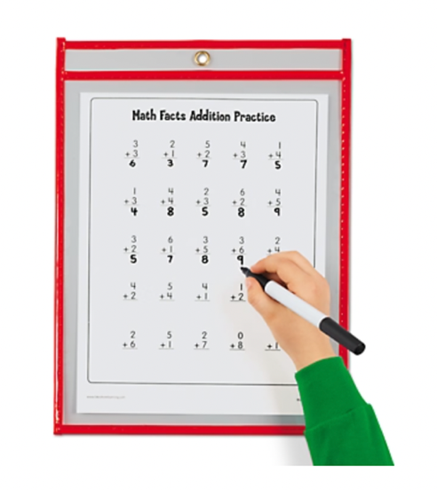

Who Might Benefit?
Those who demonstrate motor challenges around needing reduced resistance or a smooth surface, or fatigue with writing/drawing activities.
Why Use?
An opportunity to make marks with minimal pressure, easily erase or alter writing/drawing, and multiple chances to complete the same activity to gain competency.
Instructions for Use: | Adaptation Ideas:
Environmental Considerations  - Use in any environment.  Positioning & Alternate Positioning  - Use in any position; seated, standing, on the floor, with a slanted surface, on an easel/wall.  Basic Play/Use Extended Play/Use  - Creative drawing or prewriting activities like tracing, copying, and coloring. Turn-taking with games like tic-tac-toe. | Stabilize It  - Use Dycem/shelf liner, tape to table or clip to slant board to secure.  Contain It  - Place in a tray to contain the pocket.  Add Sensory Cues  - Add Wikki Stix or removable tactile stickers for tactile cues.  Communication Supports  - Provide a communication board with vocabulary appropriate for the activity.  Alternative Uses  - Seal the pocket with paint inside for mess free fingerpainting.

Words to Encourage Play/Use
Trace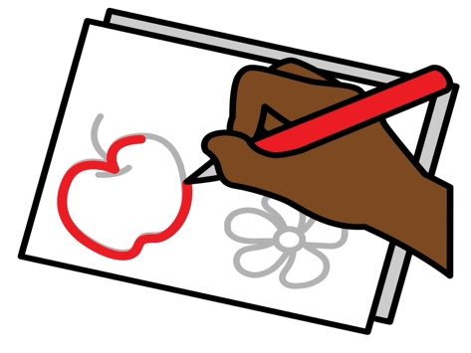 | Color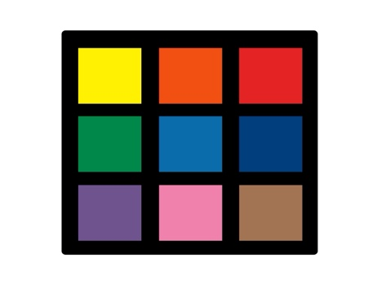 | Write
Draw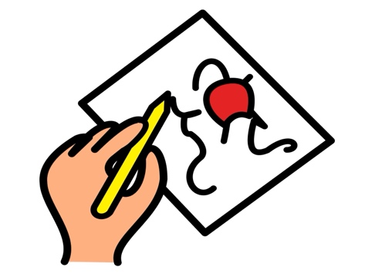 | Wipe | Erase
Go | Stop | Done
*”Adaptations” adapted from: Haugen’s Modes for Adapting Toys based on materials from the "Let's Play" Project at the University of Buffalo
PCS is a trademark of Tobii Dynavox, LLC. All rights reserved. Used with permission.

